**GROCERY ANDROID APPLICATION**

**INTRODUCTION**

*1.1 Overview*

Grocery android application where user can note down the grocery items that they are going to purchase . They can add or delete the grocery items, say vegetables, eggs etc. Grocery Products are displayed in effective graphical user interface. Users having a mobile phone can access this easy-to-use application so that they don’t forget the things to buy while going for grocery shopping. In this project, I've used MVVM(Model View ViewModel ) for architectural patterns, Room for database, Coroutines and Recycler View to display the list of items.

MVVM architecture in android is used to give structure to the project’s code and understand code easily. MVVM is an architectural design pattern in android. MVVM treat Activity classes and XML files as View. This design pattern completely separate UI from its logic.

Room persistence library is a database management library and it is used to store the data of apps like grocery item name, grocery item quantity, and grocery item price. Room is a cover layer on SQLite which helps to perform the operation on the database easily.

RecyclerView is a container and it is used to display the collection of data in a large amount of data set that can be scrolled very effectively by maintaining a limited number of views.

Coroutines are a lightweight thread, we use a coroutine to perform an operation on other threads, by this our main thread doesn’t block and our app doesn’t crash.

*1.2 Purpose*

The purpose of this project is to provide the solution for things which are frequently skipped from our minds especially the older generation which are more vulnerable to forgetting day-to-day things. Apps like these prove to be very popular among senior citizens as handwritten shopping lists are often misplaced but once they adopt the habit of feeding the things in their phones, makes their life a lot easier and managed.

**LITERATURE SURVEY**

*2.1 Existing problem*

Forgetting to buy is both common and annoying. As consumers, we have all forgotten to buy an ingredient necessary for a meal or an item someone asked us to purchase just minutes before we entered the grocery store. For consumers, the consequences of forgetting include having to return to the store or to re-organize meal plans. Grocery shopping, either in brick and mortar or online stores, represents one of the largest household expenditures. Statistics indicate that forgetting is common, and can be substantially reduced by the simple use of shopping lists. However, many shoppers do not use a shopping list so to overcome this habit of forgetting, this app is available at their fingertips.

*2.2 Proposed solution*

This application provides a solution to the problems listed above. It provides an easy and hassle-free way to note down whatever pantry items need to be bought. Everyone nowadays has a mobile phone with them, so there is no chance of skipping things as they can quickly write down whatever comes to their mind while looking for items to be purchased. Users can view the items anytime and can delete or add items effortlessly. This app was developed in the most simplistic way keeping in view all the generations(young and old).

**THEORITICAL ANALYSIS**

*3.1 Block diagram*

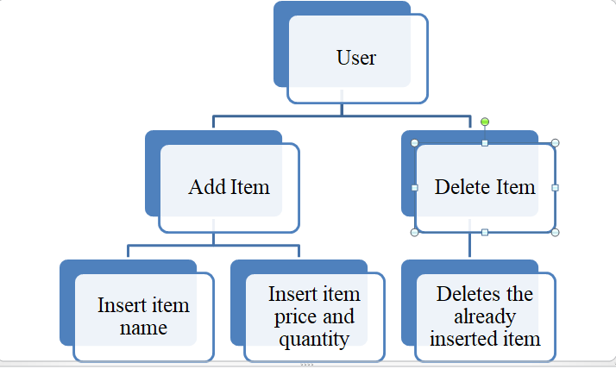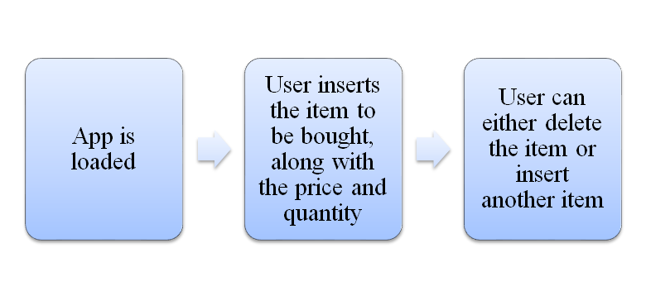

*3.2 Hardware / Software designing*

Hardware requirements:

* Microsoft® Windows® 7/8/10 (64-bit)
* 4 GB RAM minimum, 8 GB RAM recommended
* 2 GB of available disk space minimum
* 4 GB Recommended (500 MB for IDE + 1.5 GB for Android SDK and emulator system image)
* 1280 x 800 minimum screen resolution

Software requirements:

* Integrated Development Kit
* Software Development Kit
* Java Software Development Kit
* Kotlin
* Android Studio

**EXPERIMENTAL INVESTIGATION**

Each activity can be understood as a single page in the app. These activities are Java classes. The layout of a screen is described in the activity called XML file. In this app, only linear layout is used along with two [ImageView](https://www.geeksforgeeks.org/imageview-in-kotlin/) , [RecyclerView](https://www.geeksforgeeks.org/android-recyclerview/), and [Button](https://www.geeksforgeeks.org/button-in-kotlin/) after clicking this button a **DialogBox** open and in that dialog box user can enter the item name, item quantity, and item price. The first page of the app is a homepage which is initially empty in which items needs to be added. A dialog box appears having three text boxes and two buttons. First text box demands the item name, second stores item quantity and third stores item price. Two buttons are there, one is used for adding the item and the other is used for cancelling the item that can be due to mistake in adding any of the above text fields or the user no longer wants the item.

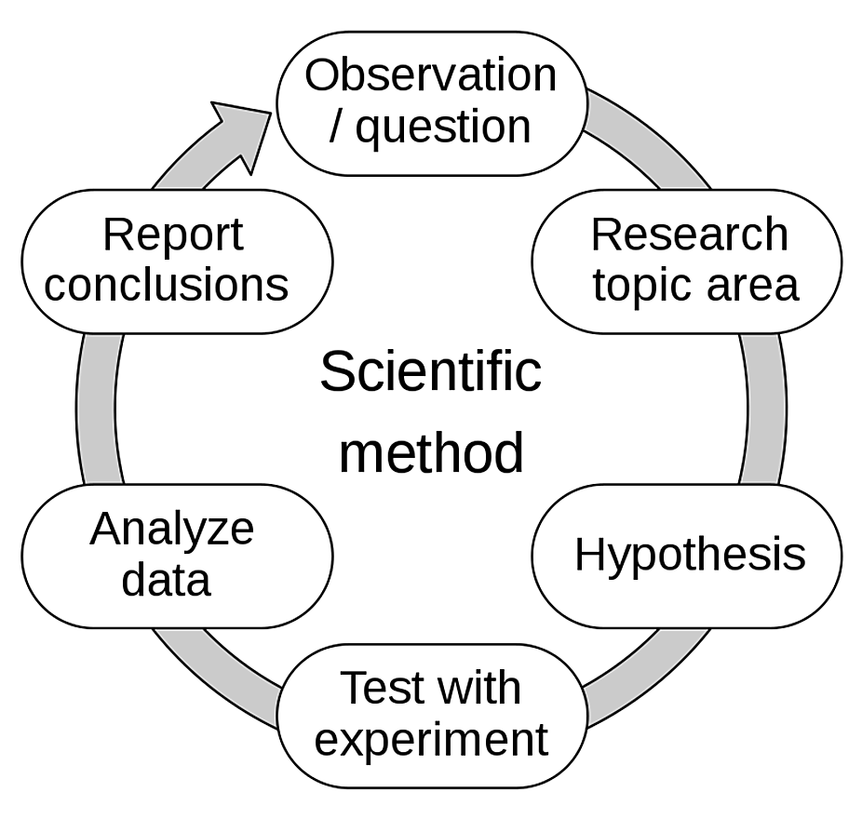

**FLOWCHART**

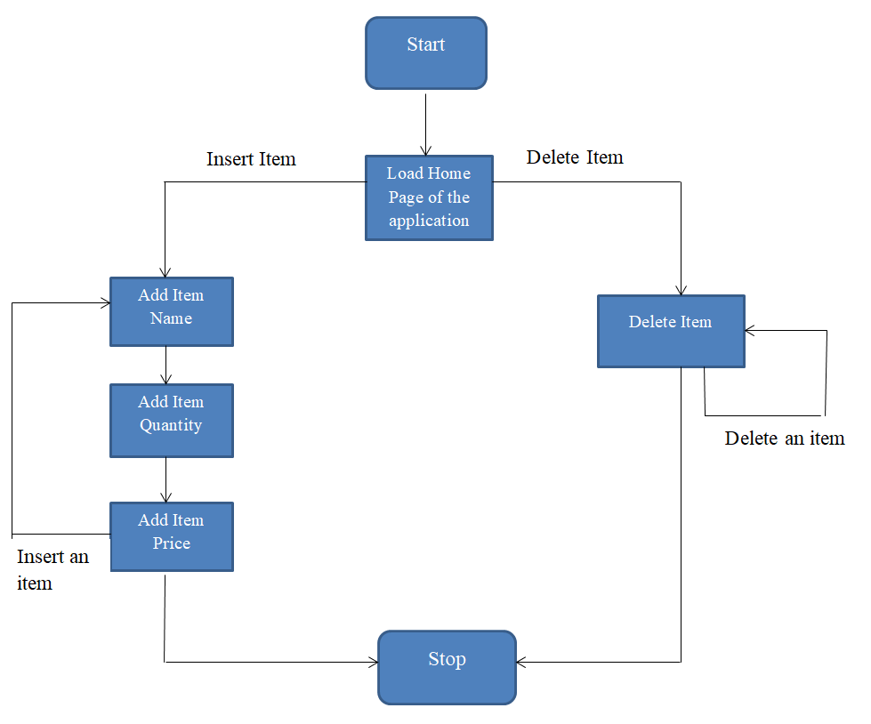

The above flowchart shows how the grocery android app works. The application is loaded then it is checked if an item is to be added or deleted. If the user needs to add an item then they need to add the item name, item quantity along with item price to insert the item or press delete to delete an already inserted item.

**RESULT**

Below attached are the snapshots of the application and it can be seen that we can insert any number of items by clicking the '+' sign along with their names, the quantity and the price of one quantity of that item. Whenever we realize that the item is not needed anymore or we have bought the item, it can be deleted by clicking on the bin icon.

Homepage of the app

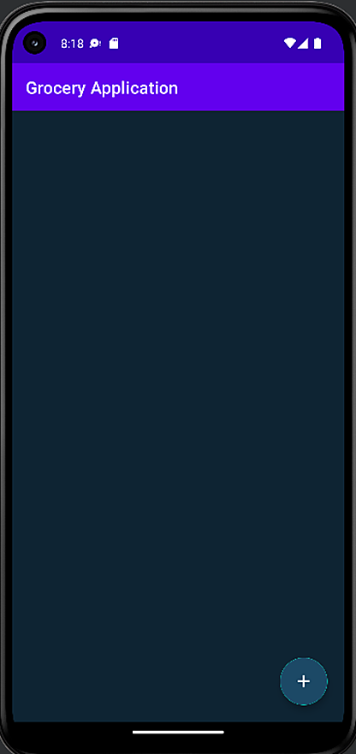

Inserting an item

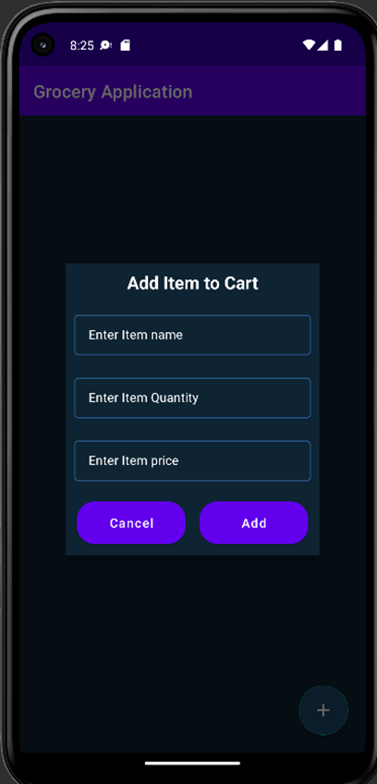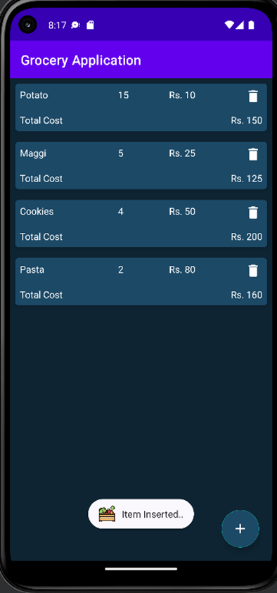

Deleting an item

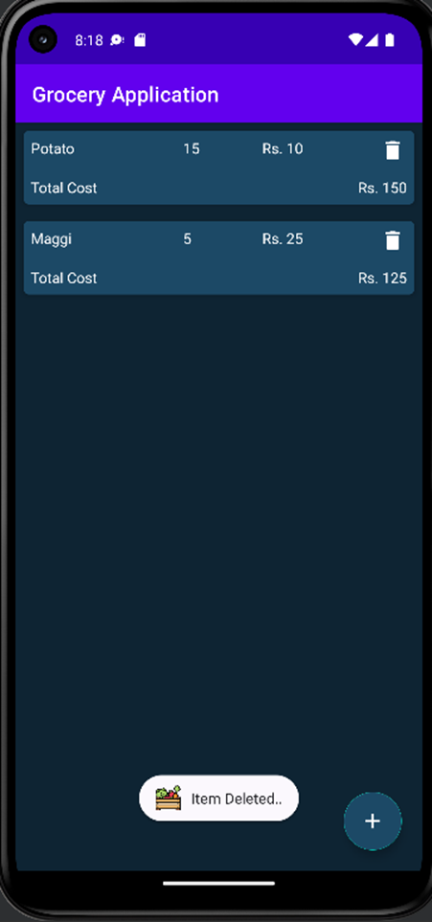

**ADVANTAGES AND DISADVANTAGES**

*Advantages:*

* A grocery list helps you plan your budget.
* The grocery application saves you a lot of your time by grabbing your attention to only the specific things which needs to be purchased.
* There will be less trips to the shops as you simply head to the shops once with all you need written down and stops impulse buys.
* You’ll be able to make smarter decisions and properly evaluate the types of food that you and your family are consuming. Instead of making last-minute unhealthy decisions, you can stick to a healthier trip.
* If you’re someone that gets anxious or stressed going to the shops, this is a big help. Having a list and something to follow during the hustle and bustle is incredibly useful.

*Disadvantages:*

* The price of the grocery items can change from time to time which will make your budget unstable.
* Maintaining the list of items to buy is no bad but the problem starts when we get too dependent on our phones that we fail to remember even the smallest things.

**APPLICATIONS**

The proposed solution can be applied in following areas:

1. 56% of the older population (age 52-75 yrs) tends to forget things and make full use of grocery lists to stay organized.
2. Young people living alone or couples can use it to stay in budget.
3. Teenagers can make use of this application to help their parents at home. In this way they can learn to buy things in an organized and budgeted way from the onset of their lives.
4. Shopkeepers can also use it to buy supplies from the vendor in one go. They have to buy goods in large quantities so this app will prove to be a significant advancement for them.

**CONCLUSION**

I use different applications on my phone every single day, and with the way that these different technologies are revolutionizing society is truly mind blowing. I couldn't even imagine a day where I didn't have a mobile phone to check, or an app to play in my free time. This fact alone proves that app development will never be a useless skill to have, because we as a society will only grow to expand its concepts more and more. I'm very pleased to have taken on the Grocery Android Application project and to have finished it with results that were above my expectations. Developing apps is a skill that I know will help me become even more versatile and I’ll get to better the lives of people with this skill set.

**FUTURE SCOPE**

Having now completed my own first Android app, although it is not by any means perfect, I've learned a lot of the basic concepts behind making an app, which is something I never thought I would come to know. Looking ahead, some future work I could further put into this app would be significantly improved graphics. Right now, my app uses all default layouts, which I know can all be customized somehow. However, in planning for the project I wanted to focus on implementation before I spent too much time on making my project more visually appealing .

Based on the current state of my grocery list app, a future implementation I could create would be to generalize the purpose of the app altogether. For instance, instead of just making the app exclusively for grocery lists, I could broaden the purpose to just general note taking. That way the app could see multiple uses and potentially be more appealing to users.

I could potentially create my own database that I populate with all different foods from the main food retailers and allow the user to search through that database and manually add the different products they want to their grocery list. I could even save pictures of all the products that could also be included in the grocery list. That way I could renovate the way that people shop for food everyday by providing an easy to use application where you can search for any possible food you may need. If I could make the process even more elaborate, I could attempt to add functionality that would be able to say if your desired product was in stock as well as have a price range across different food chains.

**BIBLIOGRAPHY**

* <https://www.geeksforgeeks.org/how-to-build-a-grocery-android-app-using-mvvm-and-room-database/>
* <https://medium.com/swlh/android-room-persistence-library-with-a-view-in-kotlin-4d2bf87f61bc>
* <https://developer.android.com/docs>

Resources

* Android Studio
* Android Developer Guides
* AVD Manager
* Android Jetpack

Appendix

*Source code*

The solution code can be found by accessing the link below: https://github.com/smartinternz02/SPSGP-68214-Virtual-Internship---Android-Application-Development-Using-Kotlin.

THANK YOU!